**Lab 1. Write Java program to print “Hello World”**

**Source Code:**

public class Main {  
 public static void main(String[] args) {  
 System.*out*.print("Rose Dangol (28684/078) \n");  
 System.*out*.print("Lab no.1 \n\n");  
 System.*out*.print("Hello world!\n");  
 }  
}

**Output:**

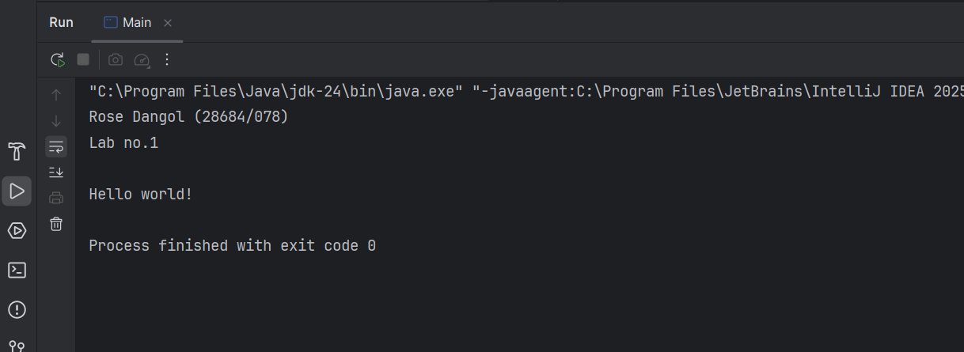

**Lab 2. Write a program in Java to read a number and tests if it is even or odd**

**Source Code:**

import java.util.Scanner;  
public class lab2 {  
 public static void main(String[] args) {  
 System.*out*.print("Rose Dangol (28684/078) \n");  
 System.*out*.print("Lab no.2 \n\n");  
 Scanner input = new Scanner(System.*in*);  
 System.*out*.print("Enter a number:");  
 int num=input.nextInt();  
 if(num%2==0)  
 System.*out*.println("The entered number is even.");  
 else  
 System.*out*.println("The entered number is odd.");   
 }  
}

**Output:**

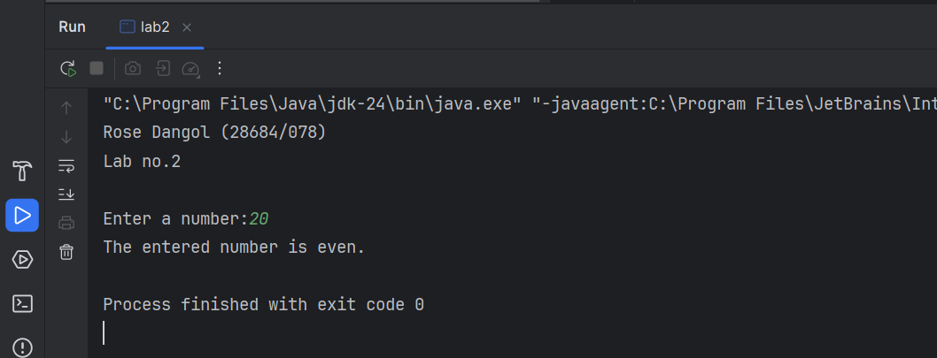

**Lab 3. Write a program that finds the largest element in an array.**

**Source Code:**

import java.util.Scanner;  
public class lab3 {  
 public static void main(String[] args) {  
 int[] numbers = new int[5];  
 System.*out*.print("Rose Dangol (28684/078) \n");  
 System.*out*.print("Lab no.3 \n\n");  
 Scanner input = new Scanner(System.*in*);  
 System.*out*.print("Enter the array numbers:");  
 for(int i=0;i<numbers.length;i++){  
 numbers[i] = input.nextInt();  
 }  
 int largest= numbers[0];  
 for(int i=1;i<5;i++){  
 if(numbers[i]>largest)  
 largest=numbers[i];   
 }  
 System.*out*.println("The largest number is: "+largest);  
 }  
}

**Output:**

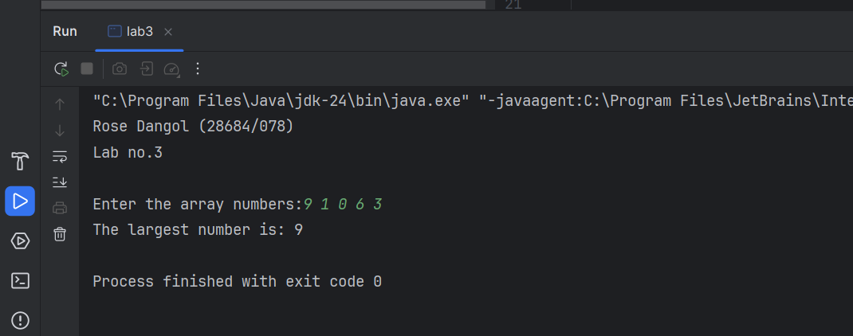

**Lab 4. Write a program in java that finds second largest element in an array**

**Source Code:**

import java.util.Scanner;  
public class lab4 {  
 public static void main(String[] args) {  
 int[] num;  
 int Size;  
 System.*out*.print("Rose Dangol (28684/078) \n");  
 System.*out*.print("Lab no.4 \n\n");  
 Scanner arraySize = new Scanner(System.*in*);  
 System.*out*.print("Enter the array size:");  
 Size= arraySize.nextInt();  
 num = new int[Size];  
 Scanner array = new Scanner(System.*in*);  
 System.*out*.print("Enter the array elements:");  
 for(int i=0;i<Size;i++){  
 num[i] = array.nextInt();  
 }  
 int largest= num[0];  
 int secondLargest=num[0];  
 for(int i=0;i<5;i++){  
 if(num[i]>largest) {  
 secondLargest = largest;  
 largest = num[i];  
 }  
 else if(num[i]>secondLargest && num[i]!=largest){  
 largest=secondLargest;  
 }  
 }  
 System.*out*.println("The second largest number is: "+secondLargest);  
 }  
}

**Output:**

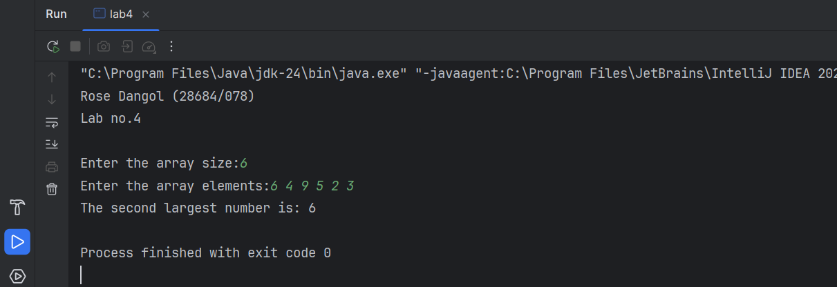

**Lab 5. Given three numbers, write a Java program to read three numbers from keyword and print out the largest of them.**

**Source Code:**

import java.util.Scanner;  
public class lab5 {  
 public static void main(String[] args) {  
 int num1,num2,num3;  
 System.*out*.print("Rose Dangol (28684/078) \n");  
 System.*out*.print("Lab no.5 \n\n");  
 Scanner input1 = new Scanner(System.*in*);  
 System.*out*.print("Enter the first number: ");  
 num1=input1.nextInt();  
 Scanner input2 = new Scanner(System.*in*);  
 System.*out*.print("Enter the second number: ");  
 num2=input2.nextInt();  
 Scanner input3 = new Scanner(System.*in*);  
 System.*out*.print("Enter the third number: ");  
 num3=input3.nextInt();  
 int result = (num1>num2&&num1>num3)?num1:(num2>num3?num2:num3);  
 System.*out*.println("The largest number is: "+result);  
 }  
}

**Output:**

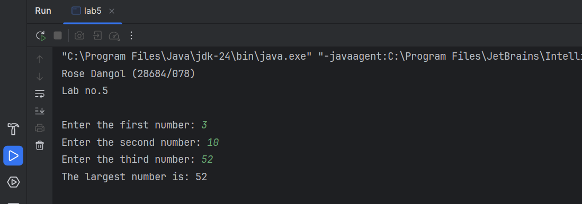

**Lab 6. Write a Java program reads a character and check if it is alphabet or not.**

**Source Code:**

import java.util.Scanner;  
public class lab6 {  
 public static void main(String[] args) {  
 char ch;  
 System.*out*.print("Rose Dangol (28684/078) \n");  
 System.*out*.print("Lab no.6 \n\n");  
 Scanner input = new Scanner(System.*in*);  
 System.*out*.print("Enter a character: ");  
 ch=input.next().charAt(0);  
 if(Character.*isAlphabetic*(ch))  
 System.*out*.printf("The entered character, %c is an alphabet \n",ch);  
 else  
 System.*out*.printf("The entered character, %c is not an alphabet \n",ch);  
 }  
}

**Output:**

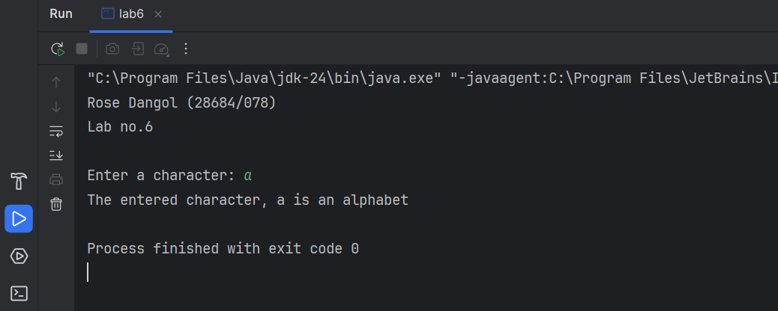

**Lab 7. Write a program that checks if the array is sorted or not.**

**Source Code:**

import java.util.Scanner;  
public class lab7 {  
 public static void main(String[] args) {  
 int[] array; int size, count=0;  
 System.*out*.print("Rose Dangol (28684/078) \n");  
 System.*out*.print("Lab no.7 \n\n");  
 Scanner sizeInput= new Scanner(System.*in*);  
 System.*out*.print("Enter the size of the array : ");  
 size=sizeInput.nextInt();  
 array=new int[size];  
 Scanner input= new Scanner(System.*in*);  
 System.*out*.print("Enter the elements of the array : ");  
 for( int i=0;i<size;i++){  
 array[i]=input.nextInt();  
 }  
 for(int i=0;i<size-1;i++){  
 if(array[i]>array[i+1])  
 count++;  
 }  
 if(count==0)  
 System.*out*.println("The given array is sorted! \n");  
 else  
 System.*out*.println("The given array is not sorted! \n");  
 }  
}

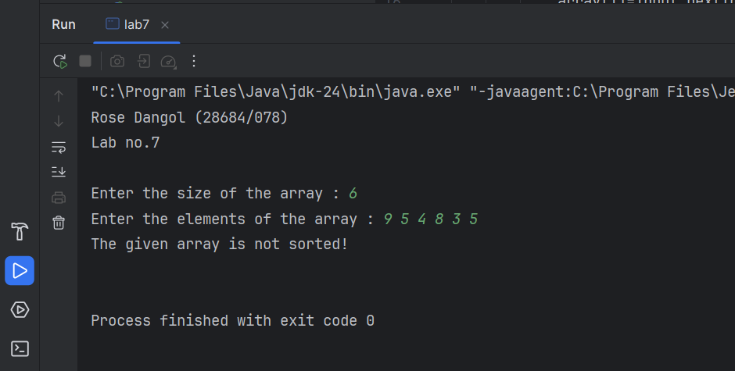**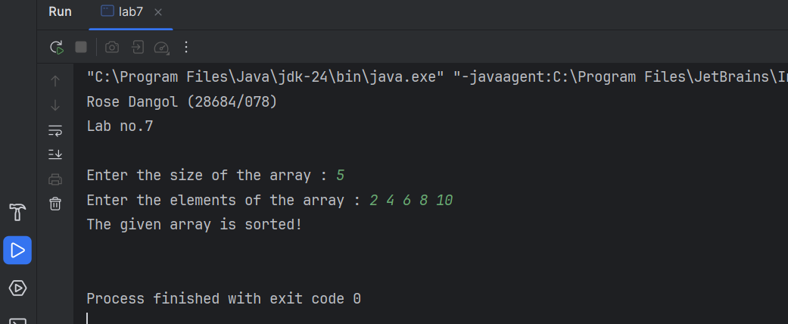Output:**

**Lab 8. Write a Java program to read two integer values m and n and to decide whether m is a multiple of n.**

**Source Code:**

import java.util.Scanner;  
public class lab8 {  
 public static void main(String[] args) {  
 int m,n;  
 System.*out*.print("Rose Dangol (28684/078) \n");  
 System.*out*.print("Lab no.8 \n\n");  
 Scanner input1 = new Scanner(System.*in*);  
 Scanner input2 = new Scanner(System.*in*);  
 System.*out*.print("Enter the first number 'm': ");  
 m=input1.nextInt();  
 System.*out*.print("Enter the second number 'n': ");  
 n=input2.nextInt();  
 if(m%n==0) System.*out*.printf("m(%d) is a multiple of n(%d)",m, n);  
 }  
}

**Output:**

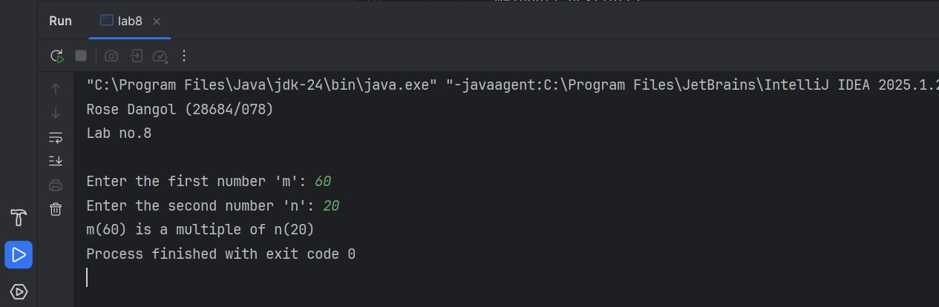

**Lab 9. Write a Java program that will obtain the length and width of a rectangle from the user and compute its area and perimeter.**

**Source Code:**

import java.util.Scanner;  
public class lab9 {  
 public static void main(String[] args) {  
 int length, width, area, perimeter;  
 System.*out*.print("Rose Dangol (28684/078) \n");  
 System.*out*.print("Lab no.9 \n\n");  
 Scanner lInput = new Scanner(System.*in*);  
 Scanner wInput= new Scanner(System.*in*);  
 System.*out*.print("Enter the length of the rectangle: ");  
 length=lInput.nextInt();  
 System.*out*.print("Enter the width of the rectangle: ");  
 width=wInput.nextInt();  
 System.*out*.println("The area of the rectangle is: " + length*width);  
 System.*out*.println("The perimeter of the rectangle is: " + 2*(length+width));  
 }  
}

**Output:**

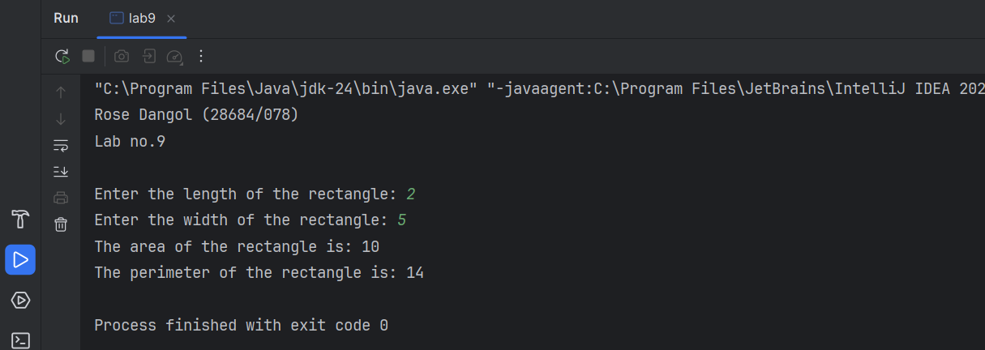

**Lab 10. Write a Java program that reads radius of circle and finds area and circumference.**

**Source Code:**

import java.util.Scanner;  
public class lab10 {  
 public static void main(String[] args) {  
 float radius;  
 System.*out*.print("Rose Dangol (28684/078) \n");  
 System.*out*.print("Lab no.10 \n\n");  
 Scanner rInput = new Scanner(System.*in*);  
 System.*out*.print("Enter the radius of the circle: ");  
 radius=rInput.nextFloat();  
 double area = 3.14*radius*radius;  
 double circumference = radius+radius;  
  
 System.*out*.println("The area of the circle is: " + area);  
 System.*out*.println("The circumference of the circle is: " + circumference);  
 }  
}

**Output:**

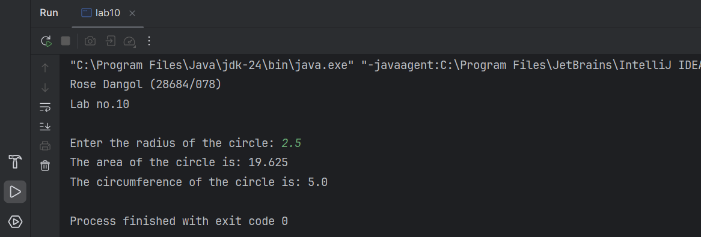

**Lab 11. Write a Java program that reads two numbers and swap them.**

**Source Code:**

import java.util.Scanner;  
public class lab11 {  
 public static void main(String[] args) {  
 int num1, num2;  
 System.*out*.print("Rose Dangol (28684/078) \n");  
 System.*out*.print("Lab no.11 \n\n");  
 Scanner input1 = new Scanner(System.*in*);  
 Scanner input2 = new Scanner(System.*in*);  
 System.*out*.print("Enter first number: ");  
 num1=input1.nextInt();  
 System.*out*.print("Enter second number: ");  
 num2=input2.nextInt();  
 System.*out*.println("\n--Before Swapping--\n");  
 System.*out*.printf("num1= %d and num2=%d\n",num1,num2);  
 int temp=num1;  
 num1=num2;  
 num2=temp;  
 System.*out*.println("\n--After Swapping--\n");  
 System.*out*.printf("num1= %d and num2=%d\n",num1,num2);  
 }  
}

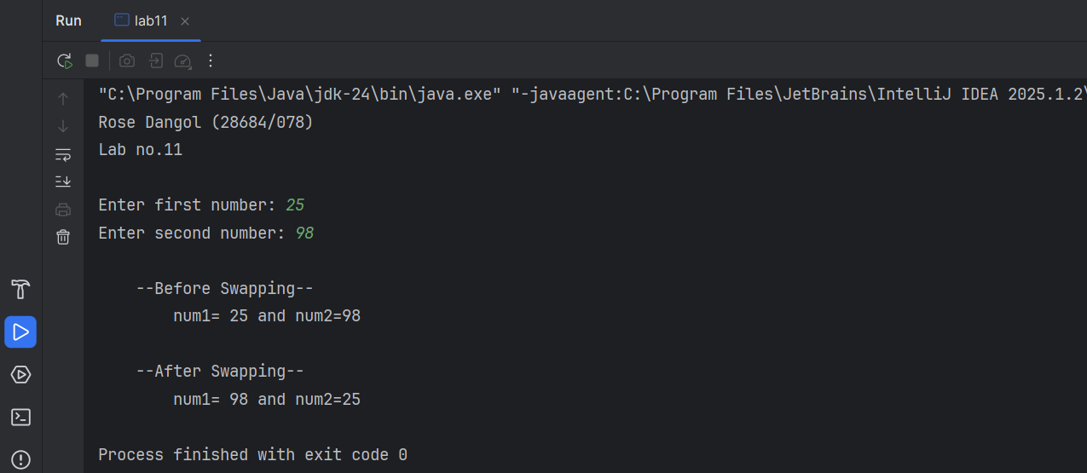**Output:**